**Comparison of Risk-Adjusted Returns: Long-Term Bonds vs Dividend Stocks**

*Sully Dawood 260679328*

December 4, 2018

**Introduction**

Historically, government/long-term bonds have been a safer investment than equities. However, stocks have also provided higher historical returns (means) relative to bonds. When it comes to investors looking for regular stream of income, bonds are recommended. Therefore, it is not uncommon to see risk-averse investors preferring to invest in bonds than stocks. However, long-term bonds are also very sensitive to the macroeconomic factors, such as interest rates, and undergo price fluctuations. Moreover they only return a fixed amount returned at the maturity. Hence, when considered in the shorter term than their maturity, these instruments cannot be given the safest heaven status.

For our targeted investor group, which are risk-averse investors (such as retirees and pension boards), we are attempting to look into comparing these options with stocks which pay considerable dividends on a periodic basis. Moreover, while it is true that these investments don't guarantee a fixed disbursement on a certain maturity date, they still offer a growth appreciation opportunity for their investors in terms of potential capital gains for their investors.

In the graph above, we have calculated trailing returns on ETF Bonds, Dividend Stocks, and the S&P 500 for the period we will analyze in this report - July 2002 to October 2018. We find that there seems to be a negative correlation between stocks and bonds. In this report, we will try to analyze the driving risk factors behind these risk factors, determine the relationship between the Dividend Stocks and long-term ETF bonds, and delve into the possibilities of maximizing our risk-adjusted return by using the said relationship.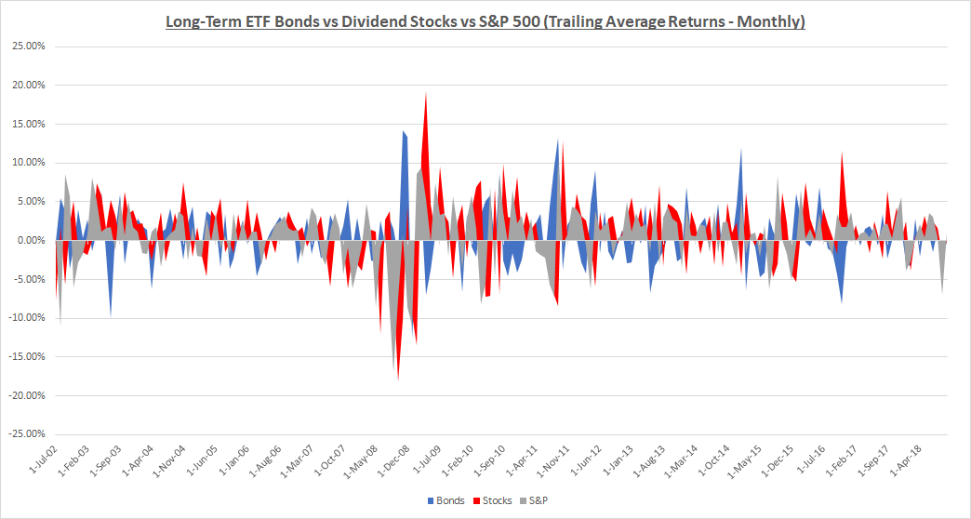

**Methodology**

Why would someone want to invest in dividend stocks instead of bonds? There is a belief that long-term government bonds and dividend stocks have similar risk/reward profiles. Especially when looking at dividend stocks with a large market cap which

might have a very low probability of default. However, they are not quite identical, and they have key differences that could make one investment more favorable than the other. While many dividend stocks may be less volatile than some other equities, they are still subject to many of the factors that impact the stock market as a whole. Thus, historically, the volatility of bonds even at their worst has been far lower than that of dividend stocks. In this case, we will consider government bonds since these are low risk investment options very appropriate for the segment we’re targeting. Also, dividends on common stock are set by the corporation. While companies generally like to maintain their dividend payout ratio there are no guarantees here. The company could potentially run into cash flow problems or decide to use some of this cash to finance internal growth rather than pay out its shareholders. So, it may seem that bonds are the safer option. But, with money market rates close to zero and other instruments at historically low rates, it is unrealistic for a retiree or other income-oriented investor to expect to live off the interest and not touch their capital. Investors looking for income need to move farther out on the risk spectrum. Thus, dividend stocks look to become a valid alternative. As a result, it becomes somewhat crucial for these types of investors to consider whether they should invest more of their wealth in long-term bonds or dividend stocks and even a combination of both. Once we compare Long-Term Bond portfolios to Dividend Stock portfolios, we will look to create a diversified portfolio, and determine if it performs better than either portfolio individually. As for evaluating the performance of these three types of investments, we will use monthly data to calculate the annualized returns, standard deviations, Sharpe Ratios and certainty equivalence returns. The standard deviation was calculated using annualized standard deviation of monthly returns.

We will also analyze risk-adjusted returns and optimal portfolios between Long-Term ETF Bonds and Dividend Stocks through creating an Efficient Frontier on the data from July 2002 to October 2018. The reason our analysis could not go further back is due to the restriction on data on long-term bonds, specifically 20-year ETF Bonds. Nevertheless, our procedure should allow us to consider optimal weights between the two Assets to analyze how to maximize returns for a given level of risk, or to minimize risk for a given level of return. Moreover, we will also consider introducing a 3-month Treasury Bill (T-Bill) into our Efficient Frontier calculation to create the tangent Capital Market Line and determine what would be the optimal portfolio weights between the two risky and one risk-free asset.

In order for us to determine which investment option will provide the best risk-adjusted return, we need to compare Sharpe Ratios for our alternatives. The Sharpe ratio is a widely-used method for calculating risk-adjusted returns and is defined as follows: $Sharpe Ratio=\frac{Portfolio Return-Risk free rate}{SD of portfolio's excess return}$

In theory, the market portfolio has the highest Sharpe ratio and is situated at the intersection of the CAL (Capital Allocation Line) and the efficient frontier. We will evaluate the optimal portfolios via this method by situating the combination of optimal portfolios containing dividend stocks and long-term bonds that we calculate on the frontier.

The purpose of our research was initially to compare long-term bonds to dividend stocks and determine which would be the better option for creating more compounded wealth. However, it’s important to note that holding both investments can provide diversification benefits since they have different sources of factor risk incorporated into them and therefore will provide a lower volatility for a portfolio consisting of both options. Thus, a new portfolio would be placed onto the efficient frontier and potentially be better than dividend stocks or long term bonds when comparing them individually.

**Data**

For our data sources, we procured the monthly data for the 1-month Treasury bill which will be used as our reference for the risk-free rate of return. For our portfolio of dividend stocks, we will only be looking at weighted-average dividend stocks situated in the middle 40% in terms of their D/P ratio. This data comes from the Kenneth French data library which constructs these portfolios on D/P at the end of each June using NYSE breakpoints and is regularly updated from stocks in the NYSE, AMEX and NASDAQ for which there is data regarding ME. In order to track long term bonds, we will be using the iShares 20+ Year Treasury Bond ETF (TLT) as a proxy since it consists of tracking investment results of an index containing U.S. Treasury bonds with remaining maturities that are greater than twenty years. Regarding our sample period, we will be evaluating

Having procured the data and set our approach towards it, we will now move onto calculating our results and analyzing them.

**Historical Mean, Volatility, and Sharpe Ratios**

We find that over the period between July 2002 to October 2018, Long-term ETF Bonds have an average monthly return of 0.56%, whereas Dividend Stocks had an average monthly return of 1.02%; moreover, their respective volatility is 3.74% and 4.5% over the period. Our analysis also finds that the covariance between the two is -0.000576 (very weak) and that the two are negatively correlated - as one would expect with these two asset classes. A summary of these results can be found below: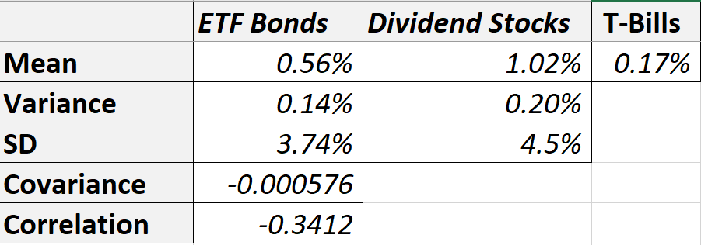

Over this period, we noticed the outperformance of dividend stocks to long term bonds:

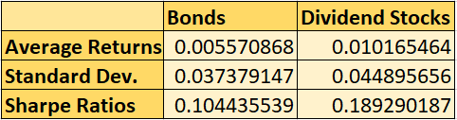

From the table above, we are able to observe that the excess return on Bonds portfolio is considerably lower than the excess return on the stocks portfolio. Furthermore, the sharpe ratio also show that the stocks portfolio has a better sharpe ratio than the bonds portfolio, which conveys that return per unit of risk in the stocks portfolio is more favorable than the return when it comes to the bonds portfolio.

**Optimal Portfolio**

Now that we have determined that investing in dividend stocks is preferable (on average) to investing in Long Term Bonds, we would now like to find an optimal portfolio of the two assets. We did this in two ways, both yielding the same results. We find the covariance matrix, and use the excel solver tool to find our optimal portfolio:

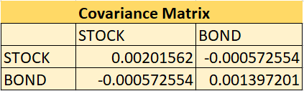

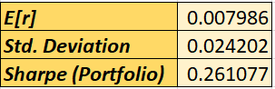 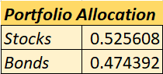

Or, using the Mean, Variance, Standard Deviation, Covariance, and Correlation calculated above, we can create the Efficient Frontier and calculate the best “reward-to-risk” ratio, which is more commonly known as the Sharpe Ratio.

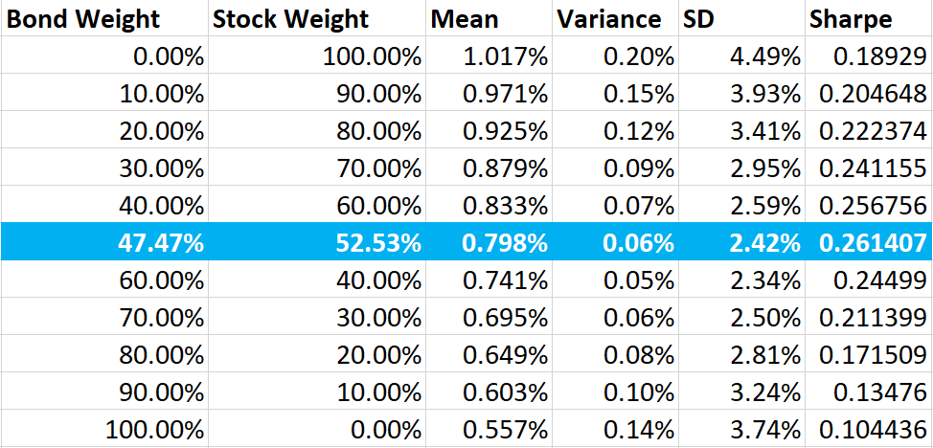

From the tables above, we can see that the highest reward-to-risk is from investing 47.47% of our portfolio into Bond ETFs and 52.53% in Dividend Stocks. Holding a portfolio with these weights statistically gives us the best Sharpe Ratio of 0.261407, and consequently the best risk-adjusted return on investment. The optimal portfolio weights were calculated using the following formula, with the monthly risk-free rate being equivalent to the T-bill rate, “A” representing Bonds, and “B” representing Stocks respectively:

From this analysis, we see a considerably larger sharpe ratio in the diversified portfolio than from using either stocks or bonds individually for investing. This improved Sharpe ratio can be largely attributed to the benefits of diversification: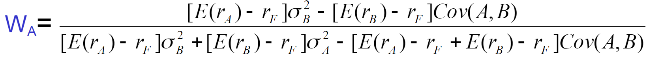

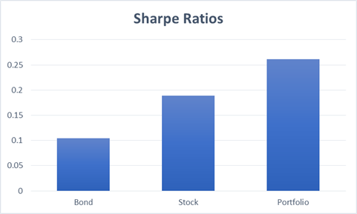

**Efficient Frontier & Capital Market Line**

Having calculated the Optimal Portfolio and it’s respective weights, we now use these weights to form a portfolio and consider the inclusion of a risk-free asset, such as T-bills. As seen from the summary at the start of this section, the average monthly risk-free rate is roughly 0.17% (or 0.167%). Therefore, The data and results calculated so far allow us to construct a Capital Allocation Line that will have a slope of 0.261407, irrespective of the weightage between the risk-free asset and our newly constructed portfolio:

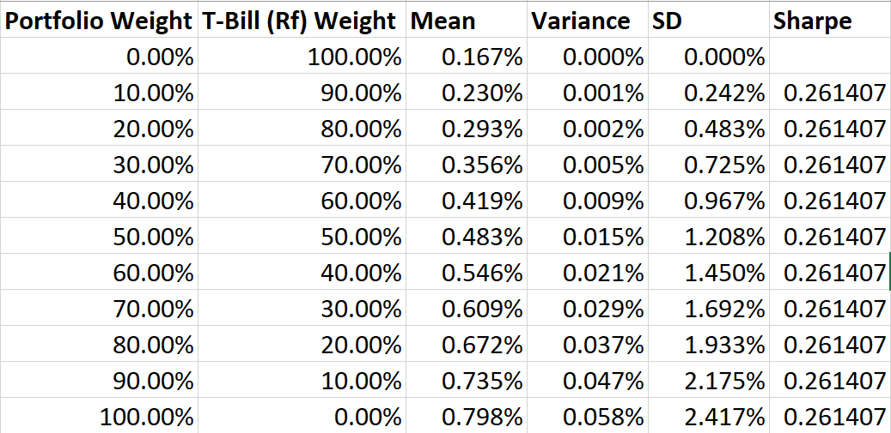

This data allows us to construct a graphical representation of the Efficient Frontier and the Capital Market Line, both of which can be seen below: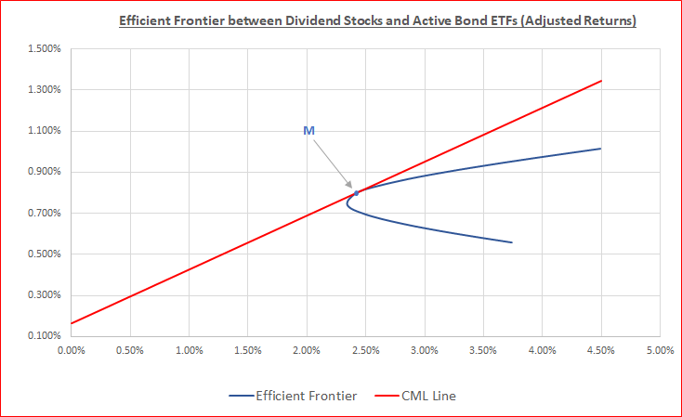

This will allow investors to make their preferred investment decisions according to their degree of risk aversion, which we will discuss in further detail in the subsequent section where we discuss the Optimal Utility with different levels of risk aversion and the Certainty Equivalence Test. The “M” marked on the graph above represents the feasible region for our risky assets (Dividend Stocks + Bond ETFs), and this is the point where the rational investor would hold the basket of our risky assets in the same proportion as a theoretically efficient market portfolio. Under CAPM, all investors that are rational and not infinitely risk-averse should hold a position in the Capital Market Line, and this graph proves that holding a position on the line maximizes return for any given level of risk.

**Optimal Utility with Varying Risk Aversion**

Next, we consider the utility function of our portfolio against multiple risk aversions. We will use this to perform the Certainty Equivalence Test: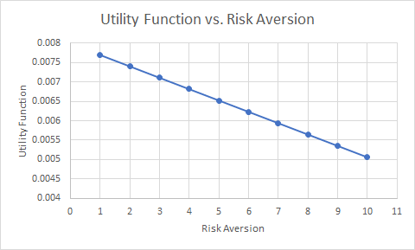

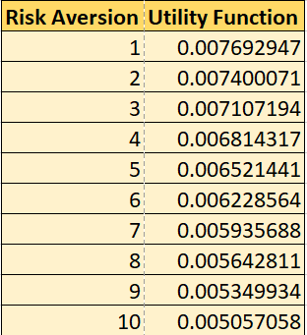

We see that, even with a highest risk aversion of 10, that our utility function exceeds the risk free rate of 0.17%. Thus, the guaranteed amount of cash that would come from investing in the risk free rate would yield less than the expected utility as a given risky asset with absolute certainty.

**Conclusion**

In conclusion, we find compelling evidence that investing in dividend stocks is a more attractive option than investing in long term bonds. Furthermore, we find that holding an optimal portfolio of the two (53% in Stocks and 47% in Bonds) can give us the ideal “reward-to-risk” ratio that minimizes risk for any given level of Expected Return. In addition to this, we find that including a risk-free asset into the portfolio helps us construct the CAL and subsequently aids in creating a portfolio of two risky and one risk-free asset, where investors can choose their ideal position on the line according to their degree of risk aversion.

With regards to risk aversion, if each asset were considered individually, it would be favorable for risk-averse investors (such as retirees) to invest in the risk-free asset. However, if the optimal portfolio is compared with the risk-free rate, we find that even with a risk aversion of 10, our portfolio gives our investors a better Utility than solely investing in the risk-free rate.

For further analysis, we could consider other criterion, like Jensen’s alpha, to further reinforce our conclusions. We also may wish to consider our data on a rolling basis. Our calculations are all done from historical means, but considering rolling returns may provide a more accurate view on our investments, as well as could better show the effects of the 2008 financial crisis on our data. Finally, a major improvement to be made is to consider a longer time period. The period used, 2002-2018, is largely affected by factors such as the 2002 downturn and the 2008 crash. Looking at data farther back may provide more accurate results. Although our results match our initial intuition, considering returns over a longer time period would help verify or contradict our findings above. Overall, our research on Dividend Stocks lead us to believe that investing in Dividend Stocks provides a superior sharpe ratio and average returns than Long Term Bonds, but investing in an optimal portfolio of the 2 assets is an improvement to the risk free rate. This creates a compelling case for retirees to invest in a diversified portfolio in order to increase their risk-adjusted returns.

**Bibliography**

* McCullum, Nick. “Dividend Stocks vs. Bonds: Comparing Risk-Adjusted Returns.” *Sure Dividend*, 20 Nov. 2017, www.suredividend.com/dividend-stocks-vs-bonds.
* French, Kenneth. “Portfolios Formed on Dividend Yield.” *Kenneth French Data Library*, mba.tuck.dartmouth.edu/pages/faculty/ken.french/data_library.html.
* “TLT : Summary for IShares 20+ Year Treasury Bond.” *Yahoo! Finance*, Yahoo!, 30 Nov. 2018, ca.finance.yahoo.com/quote/TLT?p=TLT&.tsrc=fin-srch.
* “1-Month Treasury Constant Maturity Rate.” *FRED*, Federal Reserve Bank of St. Louis, 30 Nov. 2018, fred.stlouisfed.org/series/DGS1MO.
* PAGE 212 - Equation 6.13 - Investments (Eighth CANADIAN EDITION) - Bodie, Kane, Marcus, Perrakis, Ryan